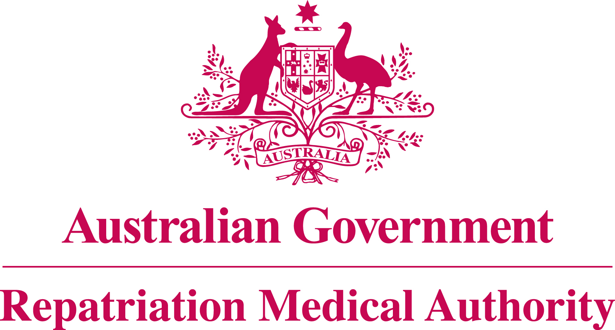

Amendment Statement of Principles

concerning

MORBID OBESITY

No. 76 of 2019

for the purposes of the

Veterans' Entitlements Act 1986
and
Military Rehabilitation and Compensation Act 2004
- This Instrument may be cited as Amendment Statement of Principles concerning morbid obesity No. 76 of 2019.
- The Repatriation Medical Authority amends, under subsection 196B(8) of the Veterans' Entitlements Act 1986, Statement of Principles concerning morbid obesity Instrument No. 6 of 2014 (Federal Register of Legislation No. F2014L00022) by:
- Replacing the definition of "morbid obesity" in clause 3(b) as follows:
"(b) For the purposes of this Statement of Principles, "morbid obesity" means an excessive accumulation of fat in the body resulting in:
(i) a Body Mass Index (BMI) of at least 40; or
(ii) in those aged 18 years or younger, a BMI of at least 120 percent of the 97th percentile in the 2007 World Health Organisation Body Mass Index Charts, for Age and Gender."; and
- Revising the definition of "BMI" in clause 9 as follows:
'"BMI" means W/H² where:
W is the person’s weight in kilograms; and
H is the person’s height in metres;'.
- The amendments made by this instrument commence on 22 July 2019.
Dated 21 June 2019
The Common Seal of the )
Repatriation Medical Authority )
was affixed to this instrument )
at the direction of: )
PROFESSOR NICHOLAS SAUNDERS AO CHAIRPERSON

