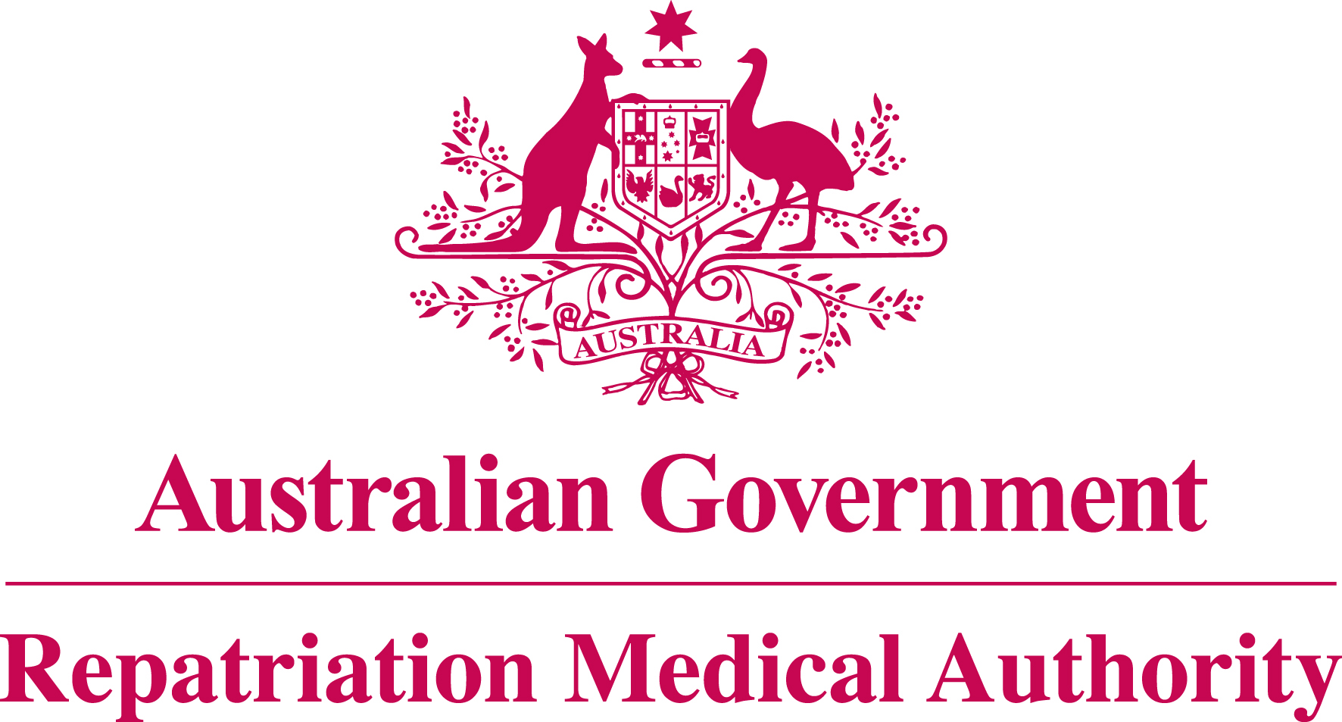

Statement of Principles

concerning

SICK SINUS SYNDROME

No. 15 of 2014

for the purposes of the

Veterans’ Entitlements Act 1986
and

Military Rehabilitation and Compensation Act 2004
Title
1. This Instrument may be cited as Statement of Principles concerning sick sinus syndrome No. 15 of 2014.
Determination
2. This Statement of Principles is determined by the Repatriation Medical Authority under subsection 196B(2) of the Veterans’ Entitlements Act 1986 (the VEA).
Kind of injury, disease or death
3. (a) This Statement of Principles is about sick sinus syndrome and death from sick sinus syndrome.
(b) For the purposes of this Statement of Principles, "sick sinus syndrome" means a group of cardiac arrhythmias caused by acquired intrinsic or extrinsic dysfunction of the sinus node, in which abnormalities of cardiac impulse formation and propagation cause an atrial rate inappropriate for physiological requirements, and where documented sinus node dysfunction correlates with symptoms. Sick sinus syndrome can manifest as persistent or intermittent sinus bradycardia, sinus pause or sinus arrest, bradycardia-tachycardia syndrome, or other arrhythmias. Sick sinus syndrome is also known as sinus node dysfunction. This definition excludes congenital sick sinus syndrome.
(c) Sick sinus syndrome attracts ICD-10-AM code I49.5.
(d) In the application of this Statement of Principles, the definition of "sick sinus syndrome" is that given at paragraph 3(b) above.
Basis for determining the factors
4. The Repatriation Medical Authority is of the view that there is sound medical-scientific evidence that indicates that sick sinus syndrome and death from sick sinus syndrome can be related to relevant service rendered by veterans, members of Peacekeeping Forces, or members of the Forces under the VEA, or members under the Military Rehabilitation and Compensation Act 2004 (the MRCA).
Factors that must be related to service
5. Subject to clause 7, at least one of the factors set out in clause 6 must be related to the relevant service rendered by the person.
Factors
6. The factor that must as a minimum exist before it can be said that a reasonable hypothesis has been raised connecting sick sinus syndrome or death from sick sinus syndrome with the circumstances of a person’s relevant service is:
- having atrial fibrillation or atrial flutter at the time of the clinical onset of sick sinus syndrome; or
- having hypertension at the time of the clinical onset of sick sinus syndrome; or
- having ischaemic heart disease at the time of the clinical onset of sick sinus syndrome; or
- having cardiac failure at the time of the clinical onset of sick sinus syndrome; or
- having rheumatic fever at the time of the clinical onset of sick sinus syndrome; or
- having myocarditis within the 30 days before the clinical onset of sick sinus syndrome; or
- having pericarditis within the 30 days before the clinical onset of sick sinus syndrome; or
- having cardiomyopathy at the time of the clinical onset of sick sinus syndrome; or
- having a benign or malignant neoplasm involving the cardiac atrium at the time of the clinical onset of sick sinus syndrome; or
- having a non-neoplastic mass lesion involving the cardiac atrium at the time of the clinical onset of sick sinus syndrome; or
- having cardiac or thoracic surgery within the three months before the clinical onset of sick sinus syndrome; or
- having a surgical procedure involving general or regional anaesthesia, other than cardiac or thoracic surgery, and which requires hospitalisation, within the 30 days before the clinical onset of sick sinus syndrome; or
- experiencing penetrating trauma to the heart, excluding surgical trauma, within the three months before the clinical onset of sick sinus syndrome; or
- being treated with a drug or a drug from a class of drugs from the specified list, where that drug cannot be ceased or substituted, for at least the 30 days before the clinical onset of sick sinus syndrome; or
- undertaking strenuous, high level, endurance physical activity greater than six METs, for an average of at least twenty hours per week for a continuous period of at least five years before the clinical onset of sick sinus syndrome, and where strenuous physical activity has ceased, the clinical onset of sick sinus syndrome has occurred within five years of cessation; or
- having hypothyroidism or Hashimoto's thyroiditis at the time of the clinical onset of sick sinus syndrome; or
- experiencing a powerful, non-penetrating blow to the chest, resulting in injury warranting medical attention, within the seven days before the clinical onset of sick sinus syndrome; or
- having electrical injury at the time of the clinical onset of sick sinus syndrome; or
- having obstructive sleep apnoea within the five years before the clinical onset of sick sinus syndrome; or
- having a specified autoimmune, infiltrative or inflammatory disease involving the heart at the time of the clinical onset of sick sinus syndrome; or
- having atrial fibrillation or atrial flutter at the time of the clinical worsening of sick sinus syndrome; or
- having hypertension at the time of the clinical worsening of sick sinus syndrome; or
- having ischaemic heart disease at the time of the clinical worsening of sick sinus syndrome; or
- having cardiac failure at the time of the clinical worsening of sick sinus syndrome; or
- having rheumatic fever at the time of the clinical worsening of sick sinus syndrome; or
- having myocarditis within the 30 days before the clinical worsening of sick sinus syndrome; or
- having pericarditis within the 30 days before the clinical worsening of sick sinus syndrome; or
- having cardiomyopathy at the time of the clinical worsening of sick sinus syndrome; or
- having a benign or malignant neoplasm involving the cardiac atrium at the time of the clinical worsening of sick sinus syndrome; or
- having a non-neoplastic mass lesion involving the cardiac atrium at the time of the clinical worsening of sick sinus syndrome; or
- having cardiac or thoracic surgery within the three months before the clinical worsening of sick sinus syndrome; or
- having a surgical procedure involving general or regional anaesthesia, other than cardiac or thoracic surgery, and which requires hospitalisation, within the 30 days before the clinical worsening of sick sinus syndrome; or
- experiencing penetrating trauma to the heart, excluding surgical trauma, within the three months before the clinical worsening of sick sinus syndrome; or
- being treated with a drug or a drug from a class of drugs from the specified list, where that drug cannot be ceased or substituted, for at least the 30 days before the clinical worsening of sick sinus syndrome; or
- having hypothyroidism or Hashimoto's thyroiditis at the time of the clinical worsening of sick sinus syndrome; or
- experiencing a powerful, non-penetrating blow to the chest, resulting in injury warranting medical attention, within the seven days before the clinical worsening of sick sinus syndrome; or
- having electrical injury at the time of the clinical worsening of sick sinus syndrome; or
- having obstructive sleep apnoea within the five years before the clinical worsening of sick sinus syndrome; or
- having a specified autoimmune, infiltrative or inflammatory disease involving the heart at the time of the clinical worsening of sick sinus syndrome; or
- inability to obtain appropriate clinical management for sick sinus syndrome.
Factors that apply only to material contribution or aggravation
7. Paragraphs 6(u) to 6(nn) apply only to material contribution to, or aggravation of, sick sinus syndrome where the person’s sick sinus syndrome was suffered or contracted before or during (but not arising out of) the person’s relevant service.
Inclusion of Statements of Principles
8. In this Statement of Principles if a relevant factor applies and that factor includes an injury or disease in respect of which there is a Statement of Principles then the factors in that last mentioned Statement of Principles apply in accordance with the terms of that Statement of Principles as in force from time to time.
Other definitions
9. For the purposes of this Statement of Principles:
"a drug or a drug from a class of drugs from the specified list" means:
- a general or epidural anaesthetic;
- acetylcholinesterase inhibitors;
- antidepressants, including amitriptyline;
- antihypertensives, including clonidine and methyldopa;
- antipsychotic phenothiazines;
- beta blockers;
- calcium channel blockers;
- cardiac glycosides, including digoxin;
- class 1A, class 1C or class III anti-arrhythmic agents;
- lithium; or
- propoxyphene (dextropropoxyphene);
"a specified autoimmune, infiltrative or inflammatory disease" means:
- amyloidosis;
- haemochromatosis;
- rheumatoid arthritis;
- sarcoidosis;
- systemic lupus erythematosus; or
- systemic sclerosis;
"death from sick sinus syndrome" in relation to a person includes death from a terminal event or condition that was contributed to by the person’s sick sinus syndrome;
"ICD-10-AM code" means a number assigned to a particular kind of injury or disease in The International Statistical Classification of Diseases and Related Health Problems, 10th Revision, Australian Modification (ICD-10-AM), Eighth Edition, effective date of 1 July 2013, copyrighted by the Independent Hospital Pricing Authority, and having ISBN 978-1-74128-213-9;
"MET" means a unit of measurement of the level of physical exertion. 1 MET = 3.5 ml of oxygen/kg of body weight per minute, or 1.0 kcal/kg of body weight per hour, or resting metabolic rate;
"relevant service" means:
- operational service under the VEA;
- peacekeeping service under the VEA;
- hazardous service under the VEA;
- British nuclear test defence service under the VEA;
- warlike service under the MRCA; or
- non-warlike service under the MRCA;
"terminal event" means the proximate or ultimate cause of death and includes:
- pneumonia;
- respiratory failure;
- cardiac arrest;
- circulatory failure; or
- cessation of brain function.
Date of effect
10. This Instrument takes effect from 15 January 2014.
Dated this nineteenth day of December 2013
The Common Seal of the )
Repatriation Medical Authority )
was affixed at the direction of: )

PROFESSOR NICHOLAS SAUNDERS AO

CHAIRPERSON

