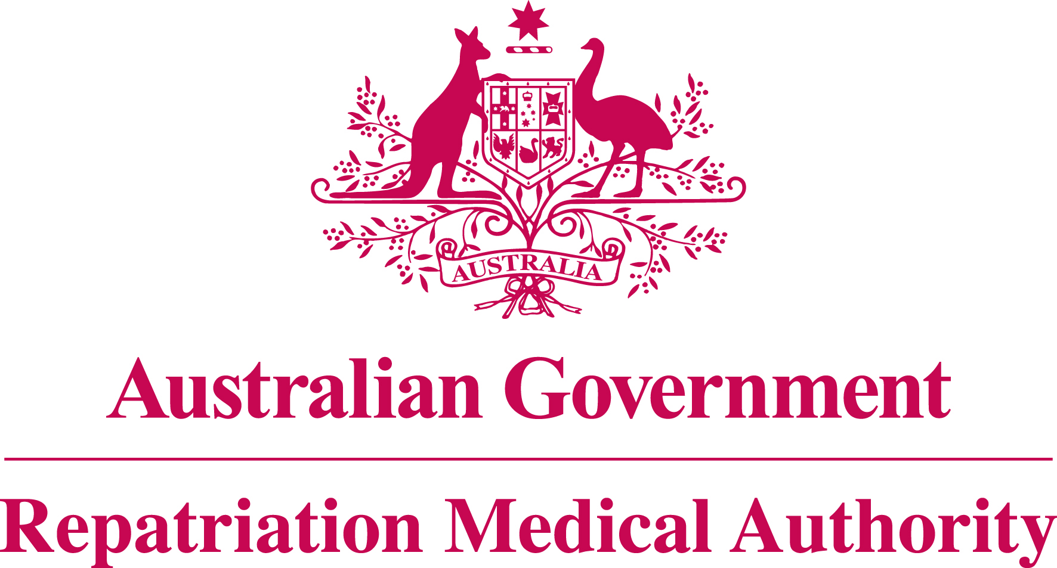

Statement of Principles

concerning

WARTS

No. 70 of 2014

for the purposes of the

Veterans’ Entitlements Act 1986
and

Military Rehabilitation and Compensation Act 2004
Title
1. This Instrument may be cited as Statement of Principles concerning warts No. 70 of 2014.
Determination
2. This Statement of Principles is determined by the Repatriation Medical Authority under subsection 196B(2) of the Veterans’ Entitlements Act 1986 (the VEA).
Kind of injury, disease or death
3. (a) This Statement of Principles is about warts and death from warts.
(b) For the purposes of this Statement of Principles, "warts" means benign epidermal growth caused by human papillomavirus (HPV) infection. This definition includes common (verruca vulgaris), flat (verruca plana), intermediate, mosaic, periungal and plantar (verruca plantaris) warts and warts of the cervix uteri and anogenital region. This definition excludes papilloma of the bladder or larynx.
(c) Warts attracts ICD-10-AM code A63.0 or B07.
(d) In the application of this Statement of Principles, the definition of "warts" is that given at paragraph 3(b) above.
Basis for determining the factors
4. The Repatriation Medical Authority is of the view that there is sound medical-scientific evidence that indicates that warts and death from warts can be related to relevant service rendered by veterans, members of Peacekeeping Forces, or members of the Forces under the VEA, or members under the Military Rehabilitation and Compensation Act 2004 (the MRCA).
Factors that must be related to service
5. Subject to clause 7, at least one of the factors set out in clause 6 must be related to the relevant service rendered by the person.
Factors
6. The factor that must as a minimum exist before it can be said that a reasonable hypothesis has been raised connecting warts or death from warts with the circumstances of a person’s relevant service is:
- having direct physical contact with a person with exposed cutaneous warts, where the contact occurs at the site of those warts, within the one year before the clinical onset of warts; or
- for warts affecting the cervix uteri and anogenital region only, having sexual intercourse with a person with cervical or anogenital warts within the one year before the clinical onset of warts; or
- for plantar warts only, using communal showering or bathing facilities within the one year before the clinical onset of warts; or
- for warts on the hands and forearms only, using shared gloves or shared utensils on more days than not for three months in the preparation of meat, poultry or fish for consumption, within the one year before the clinical onset of warts; or
- being in an immunosuppressed state at the time of the clinical onset of warts; or
- being in an immunosuppressed state at the time of the clinical worsening of warts; or
- inability to obtain appropriate clinical management for warts.
Factors that apply only to material contribution or aggravation
7. Paragraphs 6(f) to 6(g) apply only to material contribution to, or aggravation of, warts where the person’s warts was suffered or contracted before or during (but not arising out of) the person’s relevant service.
Inclusion of Statements of Principles
8. In this Statement of Principles if a relevant factor applies and that factor includes an injury or disease in respect of which there is a Statement of Principles then the factors in that last mentioned Statement of Principles apply in accordance with the terms of that Statement of Principles as in force from time to time.
Other definitions
9. For the purposes of this Statement of Principles:
"an immunosuppressed state" means a condition in which the immune response is substantially diminished. Examples of circumstances giving rise to this include haematological or solid organ malignancy, administration of immunosuppressive drugs, acute exposure to high doses of ionising radiation, severe malnutrition and human immunodeficiency virus infection;
"death from warts" in relation to a person includes death from a terminal event or condition that was contributed to by the person’s warts;
"ICD-10-AM code" means a number assigned to a particular kind of injury or disease in The International Statistical Classification of Diseases and Related Health Problems, 10th Revision, Australian Modification (ICD-10-AM), Eighth Edition, effective date of 1 July 2013, copyrighted by the Independent Hospital Pricing Authority, and having ISBN 978-1-74128-213-9;
"relevant service" means:
- operational service under the VEA;
- peacekeeping service under the VEA;
- hazardous service under the VEA;
- British nuclear test defence service under the VEA;
- warlike service under the MRCA; or
- non-warlike service under the MRCA;
"terminal event" means the proximate or ultimate cause of death and includes:
- pneumonia;
- respiratory failure;
- cardiac arrest;
- circulatory failure; or
- cessation of brain function.
Date of effect
10. This Instrument takes effect from 2 July 2014.
Dated this twentieth day of June 2014
The Common Seal of the )
Repatriation Medical Authority )
was affixed at the direction of: )

PROFESSOR NICHOLAS SAUNDERS AO
CHAIRPERSON

