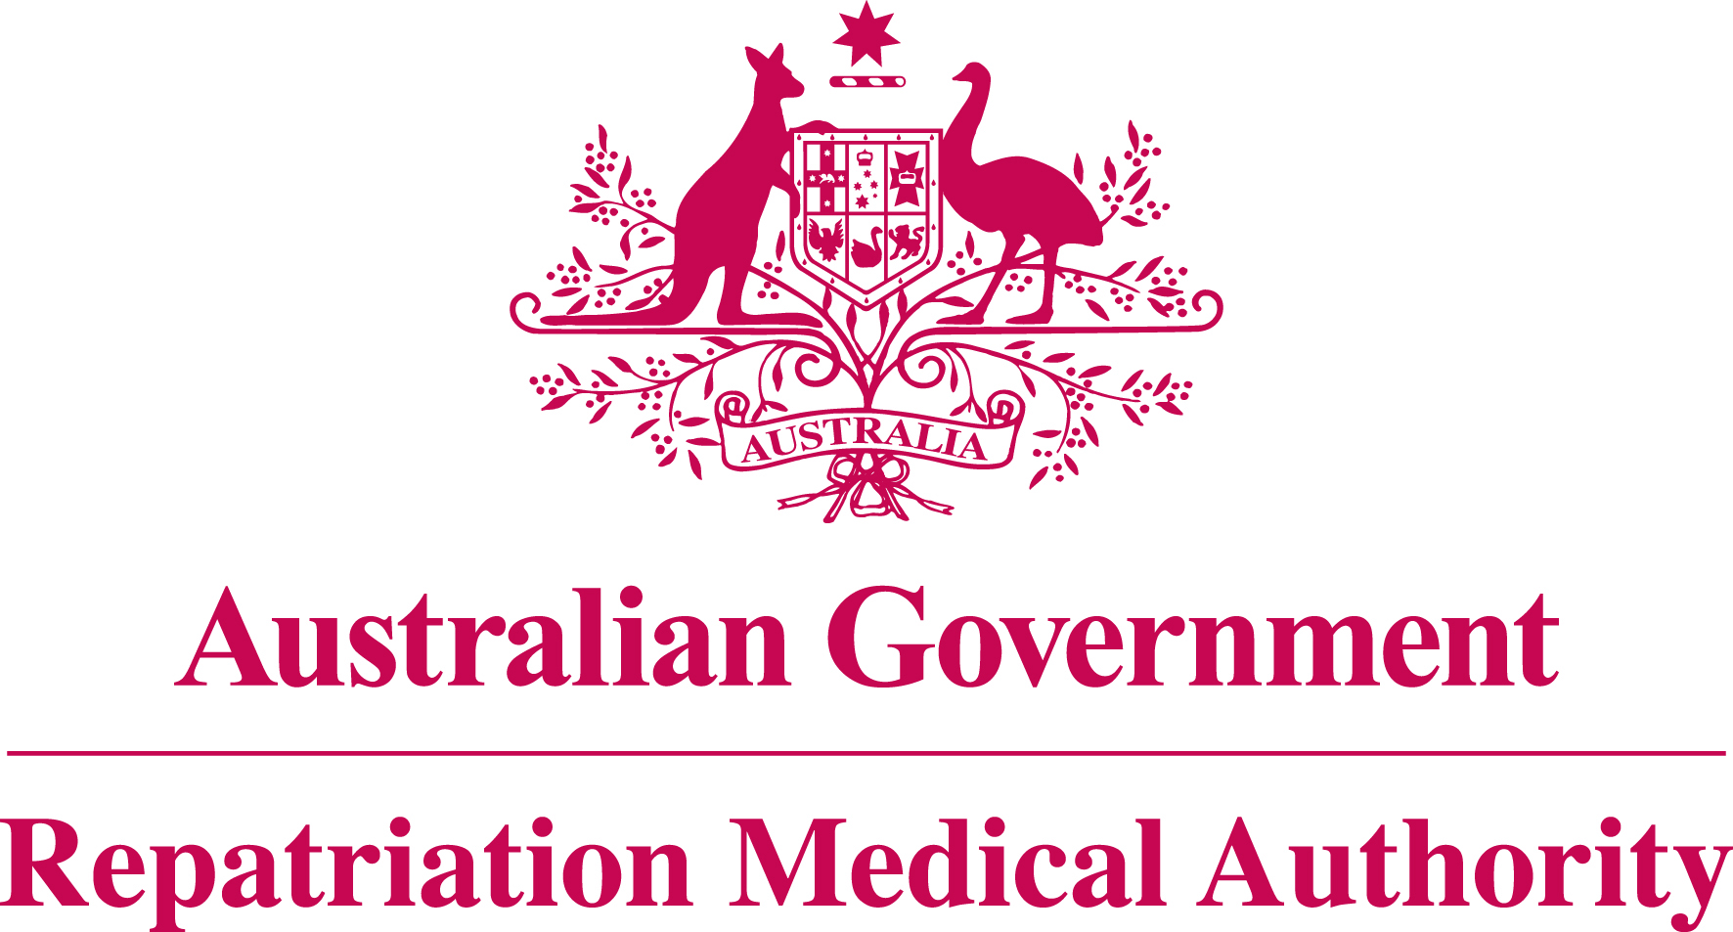

Statement of Principles

concerning

IRRITANT CONTACT DERMATITIS

No. 111 of 2011

for the purposes of the

Veterans’ Entitlements Act 1986
and
Military Rehabilitation and Compensation Act 2004

Title
1. This Instrument may be cited as Statement of Principles concerning irritant contact dermatitis No. 111 of 2011.

Determination
2. The Repatriation Medical Authority under subsection 196B(3) and (8) of the Veterans’ Entitlements Act 1986 (the VEA):
(a) revokes Instrument No. 66 of 1997, as amended by Instrument No. 24 of 2004, concerning contact dermatitis; and
(b) determines in their place this Statement of Principles.

Kind of injury, disease or death
3. (a) This Statement of Principles is about irritant contact dermatitis and death from irritant contact dermatitis.
- For the purposes of this Statement of Principles, "irritant contact dermatitis" means inflammation of an area of the skin resulting from direct contact with a chemical or biological agent. Irritants act by direct chemical or physical action on the skin, leading to disruption of the skin barrier, damage to epidermal cells and release of pro-inflammatory mediators, and induction of the innate immune system. This definition excludes allergic contact dermatitis, photocontact dermatitis, systemic contact dermatitis, urticaria and dermatitis due to exposure to extremes of weather, solar radiation (for example, solar skin damage) or other radiation or friction.
- Irritant contact dermatitis attracts ICD-10-AM code L24.
- In the application of this Statement of Principles, the definition of "irritant contact dermatitis" is that given at paragraph 3(b) above.

Basis for determining the factors
4. On the sound medical-scientific evidence available, the Repatriation Medical Authority is of the view that it is more probable than not that irritant contact dermatitis and death from irritant contact dermatitis can be related to relevant service rendered by veterans or members of the Forces under the VEA, or members under the Military Rehabilitation and Compensation Act 2004 (the MRCA).

Factors that must be related to service
5. Subject to clause 7, at least one of the factors set out in clause 6 must be related to the relevant service rendered by the person.

Factors
6. The factor that must exist before it can be said that, on the balance of probabilities, irritant contact dermatitis or death from irritant contact dermatitis is connected with the circumstances of a person’s relevant service is:

- having direct cutaneous exposure of the affected area to an irritant within the three days before the clinical onset of irritant contact dermatitis; or

- having direct cutaneous exposure of the affected area to an irritant within the three days before the clinical worsening of irritant contact dermatitis; or

- inability to obtain appropriate clinical management for irritant contact dermatitis.

Factors that apply only to material contribution or aggravation
7. Paragraphs 6(b) to 6(c) apply only to material contribution to, or aggravation of, irritant contact dermatitis where the person’s irritant contact dermatitis was suffered or contracted before or during (but not arising out of) the person’s relevant service.

Inclusion of Statements of Principles
- In this Statement of Principles if a relevant factor applies and that factor includes an injury or disease in respect of which there is a Statement of Principles then the factors in that last mentioned Statement of Principles apply in accordance with the terms of that Statement of Principles as in force from time to time.

Other definitions
- For the purposes of this Statement of Principles:

"death from irritant contact dermatitis" in relation to a person includes death from a terminal event or condition that was contributed to by the person’s irritant contact dermatitis;

"ICD-10-AM code" means a number assigned to a particular kind of injury or disease in The International Statistical Classification of Diseases and Related Health Problems, 10th Revision, Australian Modification (ICD-10-AM), Seventh Edition, effective date of 1 July 2010, copyrighted by the National Centre for Classification in Health, Sydney, NSW, and having ISBN 978 1 74210 154 5;

“irritant” means an agent or substance, for example a chemical, which damages the epidermis on contact and causes inflammation of the contacted skin. It does not include physical agents such as heat, cold, solar radiation or other forms of radiation;

"relevant service" means:
(a) eligible war service (other than operational service) under the VEA; or
(b) defence service (other than hazardous service) under the VEA; or
(c) peacetime service under the MRCA;

"terminal event" means the proximate or ultimate cause of death and includes:
(a) pneumonia;
(b) respiratory failure;
(c) cardiac arrest;
(d) circulatory failure; or
- cessation of brain function.

Application
10. This Instrument applies to all matters to which section 120B of the VEA or section 339 of the MRCA applies.

Date of effect
11. This Instrument takes effect from 31 August 2011.

Dated this nineteenth day of August 2011

The Common Seal of the )
Repatriation Medical Authority )
was affixed to this instrument )
in the presence of: )

KEN DONALD
CHAIRPERSON

