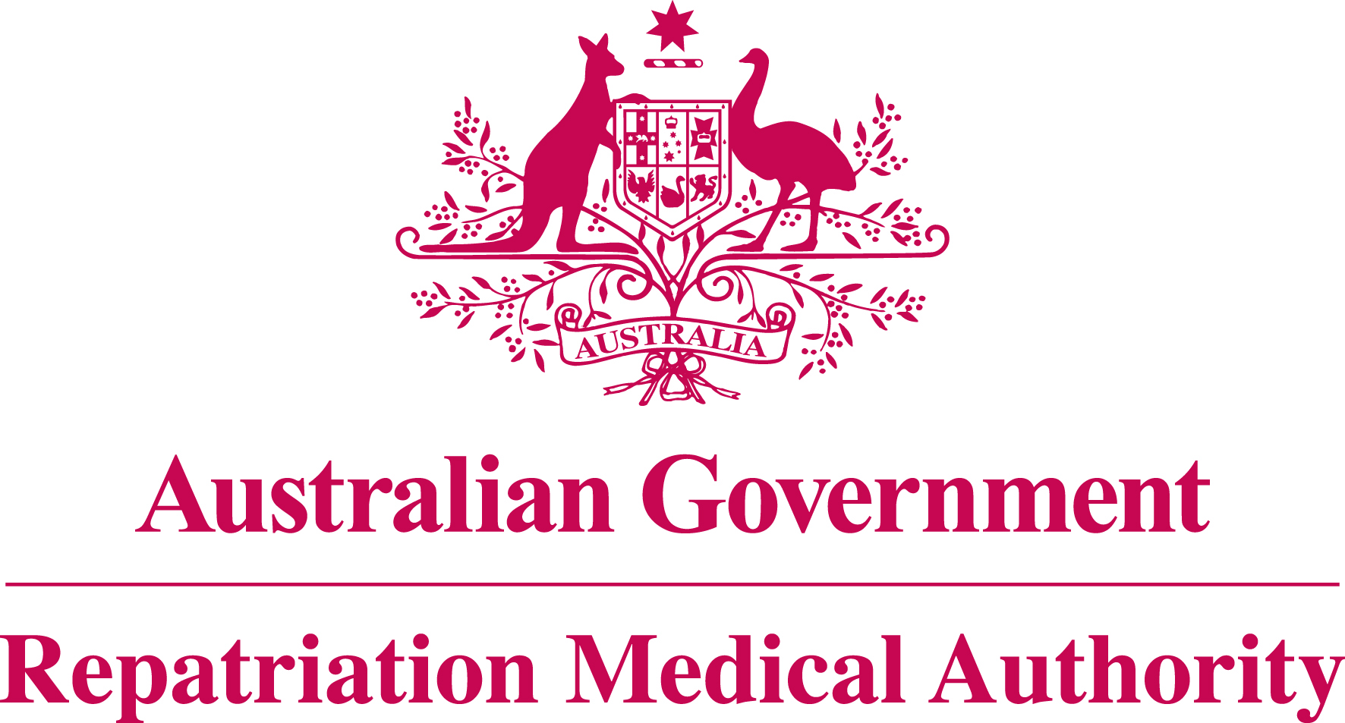

Statement of Principles

concerning

MALIGNANT NEOPLASM OF THE NASOPHARYNX

No. 25 of 2011

for the purposes of the

Veterans’ Entitlements Act 1986
and
Military Rehabilitation and Compensation Act 2004

Title
1. This Instrument may be cited as Statement of Principles concerning malignant neoplasm of the nasopharynx No. 25 of 2011.

Determination
2. The Repatriation Medical Authority under subsection 196B(2) and (8) of the Veterans’ Entitlements Act 1986 (the VEA):
(a) revokes Instrument No. 167 of 1996 concerning malignant neoplasm of the nasopharynx; and
(b) determines in its place this Statement of Principles.

Kind of injury, disease or death
3. (a) This Statement of Principles is about malignant neoplasm of the nasopharynx and death from malignant neoplasm of the nasopharynx.
- For the purposes of this Statement of Principles, "malignant neoplasm of the nasopharynx" means a primary malignancy of the mucosa of the nasopharynx, which is that part of the pharynx which lies above the level of the soft palate. This definition excludes soft tissue sarcoma, carcinoid tumour, non-Hodgkin’s lymphoma and Hodgkin’s lymphoma.
- Malignant neoplasm of the nasopharynx attracts ICD-10-AM code C11.
- In the application of this Statement of Principles, the definition of "malignant neoplasm of the nasopharynx" is that given at paragraph 3(b) above.

Basis for determining the factors
4. The Repatriation Medical Authority is of the view that there is sound medical-scientific evidence that indicates that malignant neoplasm of the nasopharynx and death from malignant neoplasm of the nasopharynx can be related to relevant service rendered by veterans, members of Peacekeeping Forces, or members of the Forces under the VEA, or members under the Military Rehabilitation and Compensation Act 2004 (the MRCA).

Factors that must be related to service
5. Subject to clause 7, at least one of the factors set out in clause 6 must be related to the relevant service rendered by the person.

Factors
6. The factor that must as a minimum exist before it can be said that a reasonable hypothesis has been raised connecting malignant neoplasm of the nasopharynx or death from malignant neoplasm of the nasopharynx with the circumstances of a person’s relevant service is:

- inhaling wood dust for at least four hours per day on more days than not for at least ten years or for a cumulative period of at least 7500 hours before the clinical onset of malignant neoplasm of the nasopharynx; or

- being infected with the Epstein-Barr virus at the time of the clinical onset of malignant neoplasm of the nasopharynx; or

- being infected with human immunodeficiency virus before the clinical onset of malignant neoplasm of the nasopharynx; or

- smoking at least 15 pack-years of cigarettes, or the equivalent thereof in other tobacco products, before the clinical onset of malignant neoplasm of the nasopharynx, and where smoking has ceased, the clinical onset has occurred within 15 years of cessation; or

- being exposed to mustard gas at least five years before the clinical onset of malignant neoplasm of the nasopharynx; or

- drinking at least 500 kilograms of alcohol before the clinical onset of malignant neoplasm of the nasopharynx; or

- inhaling formaldehyde:
- at a level of at least one part per million for at least four hours per day on more days than not for at least one year; or
- for a cumulative total of at least 750 hours;
at least 15 years before the clinical onset of malignant neoplasm of the nasopharynx; or

- working in an environment where:
- inhalational exposure to formaldehyde occurs for at least four hours per day on more days than not; and
- results in sensory irritation of the eyes or nose on at least one day per week for at least one year;
at least 15 years before the clinical onset of malignant neoplasm of the nasopharynx; or

- inhaling smoke from the combustion of wood, charcoal or coal while in an enclosed space, on more days than not for at least ten years or for a cumulative period of at least 7500 hours, before the clinical onset of malignant neoplasm of the nasopharynx; or

- having at least weekly consumption of Chinese-style salted fish for at least five years before the clinical onset of malignant neoplasm of the nasopharynx; or

- having at least weekly consumption of preserved vegetables for at least five years before the clinical onset of malignant neoplasm of the nasopharynx; or

- an inability to consume any combination of fresh fruit and vegetables on more days than not for a period of at least five consecutive years before the clinical onset of malignant neoplasm of the nasopharynx; or

- inability to obtain appropriate clinical management for malignant neoplasm of the nasopharynx.

Factors that apply only to material contribution or aggravation
7. Paragraph 6(m) applies only to material contribution to, or aggravation of, malignant neoplasm of the nasopharynx where the person’s malignant neoplasm of the nasopharynx was suffered or contracted before or during (but not arising out of) the person’s relevant service.

Inclusion of Statements of Principles
8. In this Statement of Principles if a relevant factor applies and that factor includes an injury or disease in respect of which there is a Statement of Principles then the factors in that last mentioned Statement of Principles apply in accordance with the terms of that Statement of Principles as in force from time to time.

Other definitions
9. For the purposes of this Statement of Principles:

"alcohol" is measured by the alcohol consumption calculations utilising the Australian Standard of ten grams of alcohol per standard alcoholic drink;

"Chinese-style salted fish" means fish preserved by salting and is characterised by using less salt and a higher degree of fermentation during the drying process because of the relatively high outdoor temperature and moisture levels. Chinese-style salted fish is a traditional part of the diet in southern China, Hong Kong, Taiwan, Malaysia, Singapore, other areas of south-east Asia, or in Chinese who have migrated to other countries;

"death from malignant neoplasm of the nasopharynx" in relation to a person includes death from a terminal event or condition that was contributed to by the person’s malignant neoplasm of the nasopharynx;

"ICD-10-AM code" means a number assigned to a particular kind of injury or disease in The International Statistical Classification of Diseases and Related Health Problems, 10th Revision, Australian Modification (ICD-10-AM), Seventh Edition, effective date of 1 July 2010, copyrighted by the National Centre for Classification in Health, Sydney, NSW, and having ISBN 978 1 74210 154 5;

"inhaling wood dust" means being exposed to fine particulate material of wood origin from work entailing the sanding, planing, machining, sawing, repairing or manufacturing of timber products or performing other tasks in an area where such work is being performed;

"pack-years of cigarettes, or the equivalent thereof in other tobacco products" means a calculation of consumption where one pack-year of cigarettes equals twenty tailor-made cigarettes per day for a period of one calendar year, or 7300 cigarettes. One tailor-made cigarette approximates one gram of tobacco or one gram of cigar or pipe tobacco by weight. One pack-year of tailor-made cigarettes equates to 7300 cigarettes, or 7.3 kilograms of smoking tobacco by weight. Tobacco products means either cigarettes, pipe tobacco or cigars smoked, alone or in any combination;

"preserved vegetables" means vegetables preserved by salting, fermenting or pickling;

"relevant service" means:
(a) operational service under the VEA;
(b) peacekeeping service under the VEA;
- hazardous service under the VEA;
- warlike service under the MRCA; or
- non-warlike service under the MRCA;

"terminal event" means the proximate or ultimate cause of death and includes:
(a) pneumonia;
(b) respiratory failure;
(c) cardiac arrest;
(d) circulatory failure; or
- cessation of brain function.

Application
10. This Instrument applies to all matters to which section 120A of the VEA or section 338 of the MRCA applies.

Date of effect
11. This Instrument takes effect from 25 May 2011.

Dated this ninth day of May 2011

The Common Seal of the )
Repatriation Medical Authority )
was affixed to this instrument )
in the presence of: )

KEN DONALD
CHAIRPERSON

