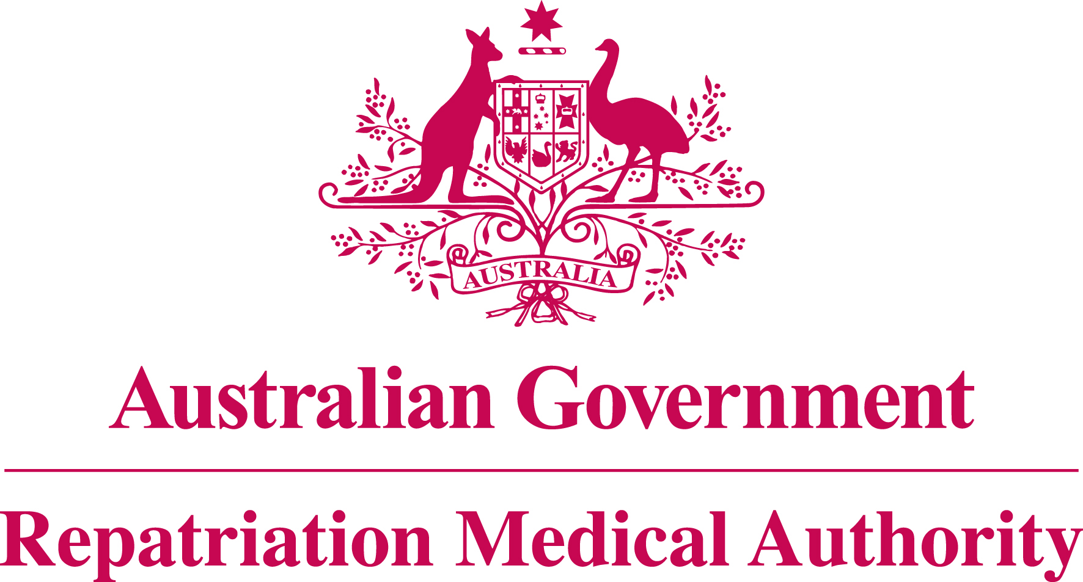

Amendment Statement of Principles

concerning

ISCHAEMIC HEART DISEASE

No. 126 of 2011

for the purposes of the

Veterans’ Entitlements Act 1986
and
Military Rehabilitation and Compensation Act 2004

- This Instrument may be cited as Statement of Principles concerning ischaemic heart disease No. 126 of 2011.

- The Repatriation Medical Authority amends, under subsection 196B(8) of the Veterans’ Entitlements Act 1986, Statement of Principles concerning ischaemic heart disease Instrument No. 90 of 2007, as amended by Instrument No. 44 of 2009 and Instrument No. 97 of 2010, by:

- Replacing existing factor "(o)" in clause 6 with the following:
"(o) using a drug belonging to the non-steroidal anti-inflammatory class of drugs, excluding aspirin, paracetamol and topical non-steroidal anti-inflammatory drugs, for a continuous period of at least seven days before the clinical onset of ischaemic heart disease, where the last dose of the drug was taken within the seven days before the clinical onset of ischaemic heart disease; or";
and
- Replacing existing factor "(ee)" in clause 6 with the following:
"(ee) using a drug belonging to the non-steroidal anti-inflammatory class of drugs, excluding aspirin, paracetamol and topical non-steroidal anti-inflammatory drugs, for a continuous period of at least seven days before the clinical worsening of ischaemic heart disease, where the last dose of the drug was taken within the seven days before the clinical worsening of ischaemic heart disease; or".

- The amendment made by this instrument applies to all matters to which Instrument No. 90 of 2007, as amended by Instrument No. 44 of 2009 and Instrument No. 97 of 2010, section 120B of the Veterans’ Entitlements Act 1986 and section 339 of the Military Rehabilitation and Compensation Act 2004 apply.

- The amendment made by this instrument takes effect from 2 November 2011.

Dated this twenty-first day of October 2011

The Common Seal of the )
Repatriation Medical Authority )
was affixed to this instrument )
in the presence of: )

KEN DONALD
CHAIRPERSON

